POWER BI CASE STUDY

Name – Ansuman Nayak

INANJJ

655475

REQUIREMENT 1 : DATA LOADING

1. CONNECTING TO SQL SERVER

1. EXECUTING QUERY TO CREATE DB

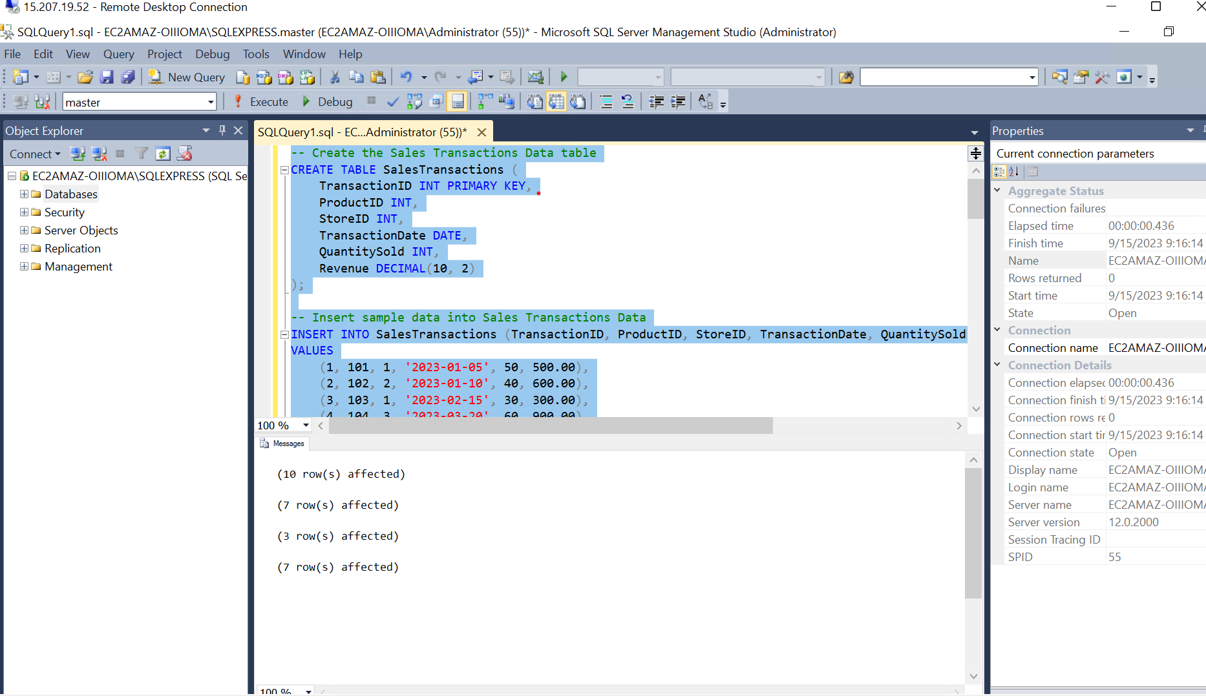

1. CONNECTING WITH DB IN SQL SERVER

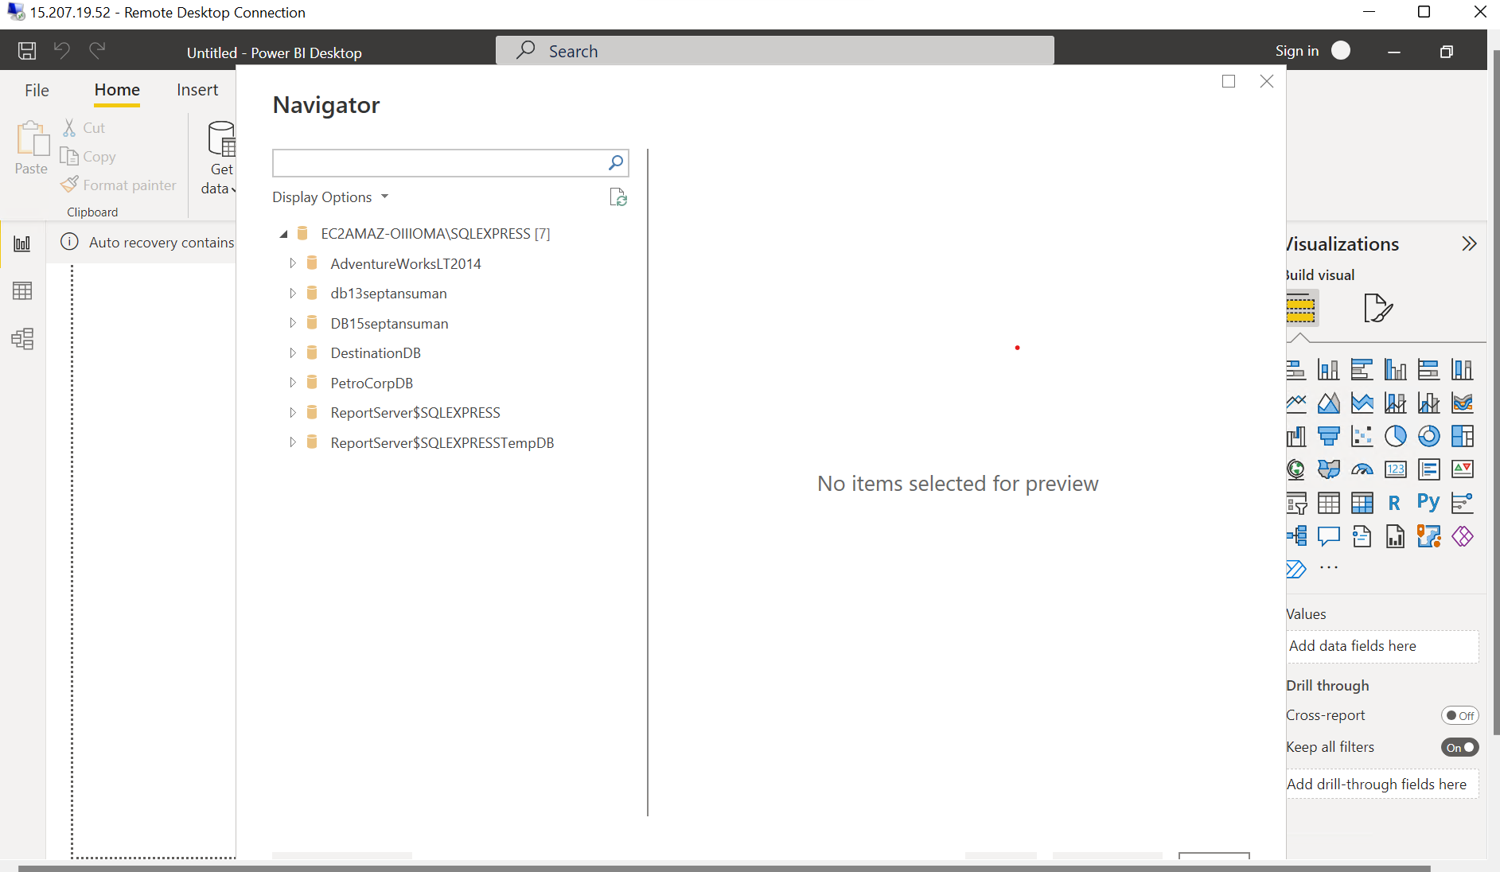

1. LOADING DATA INTO POWER BI

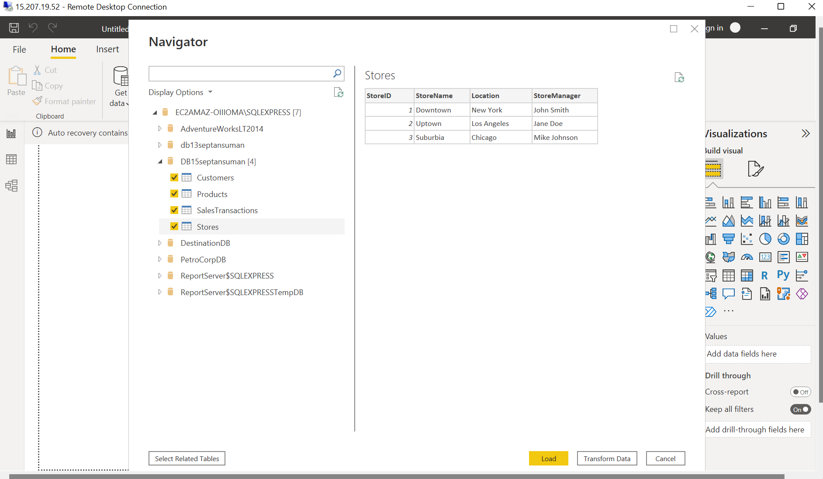

REQUIREMENT 2

MERGING TABLLES

Merging Products and SalesTransactions tables using ProductID. Storing the data in a new table

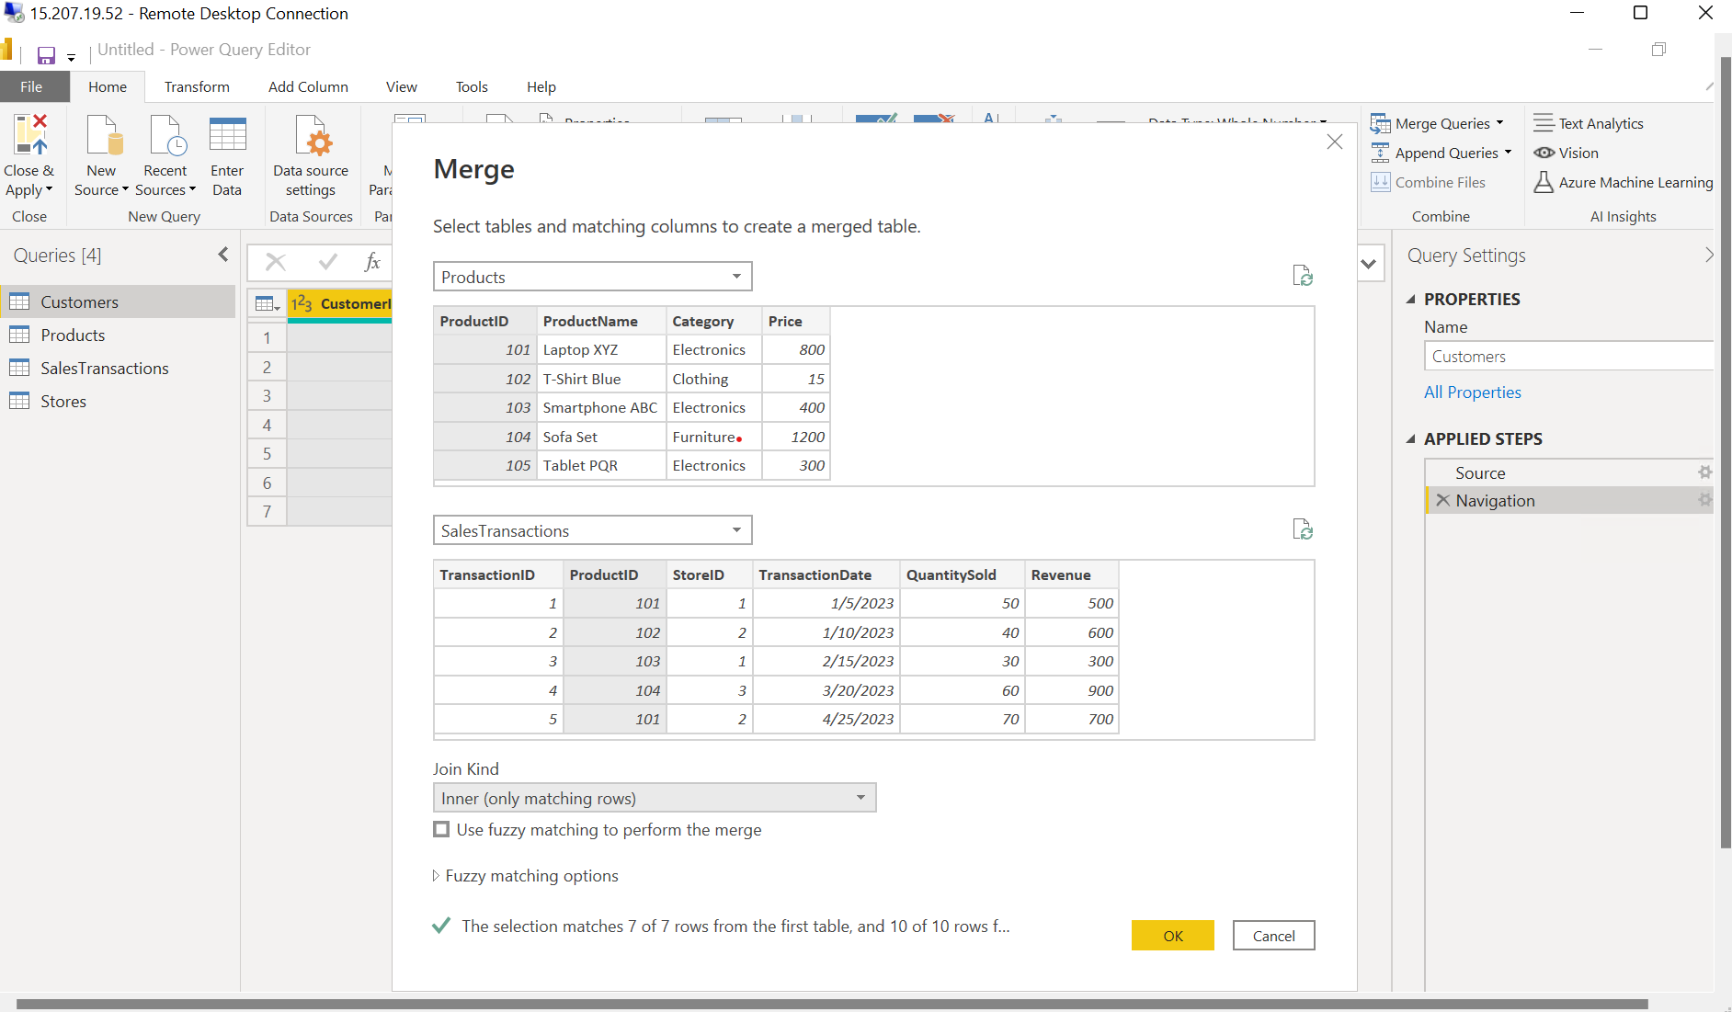

Selecting specific columns from the other table: Transaction date, QuantitySold, Revenue from Sales transaction table

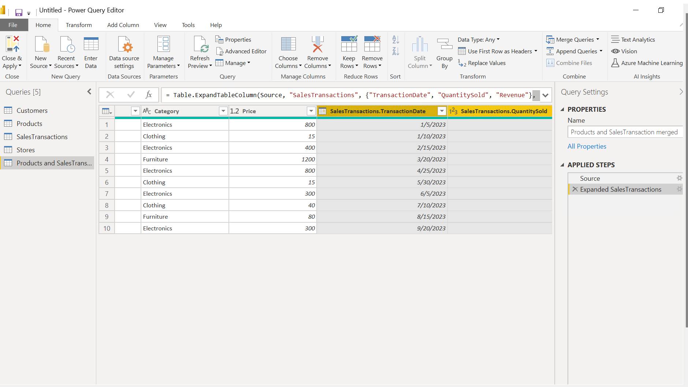

MERGING TABLES using Inner join between Products, salestransactions, stores thus creating a ultimate table

CREATING CALCULATED COLUMN

Column = Total Sales amount = Product of Quantity sold and Price of each

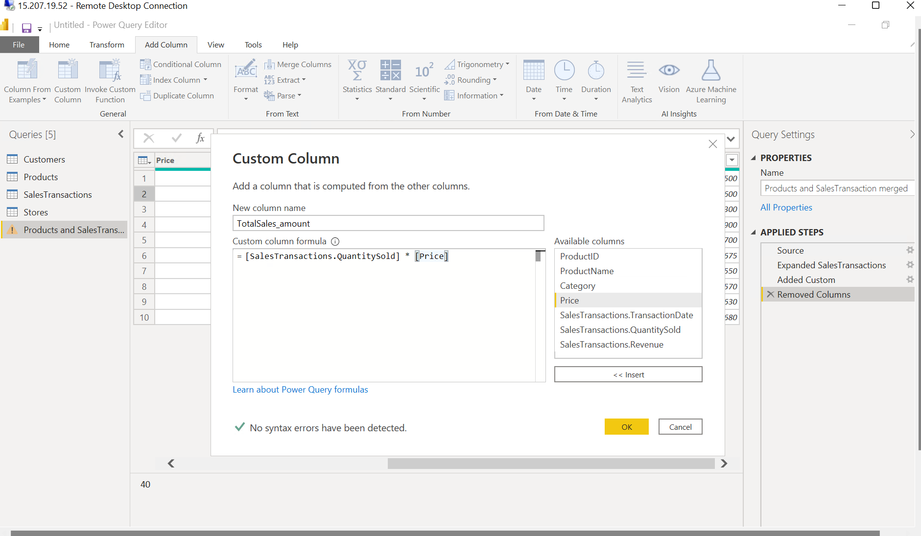

CLEAN DATA

Triming white space

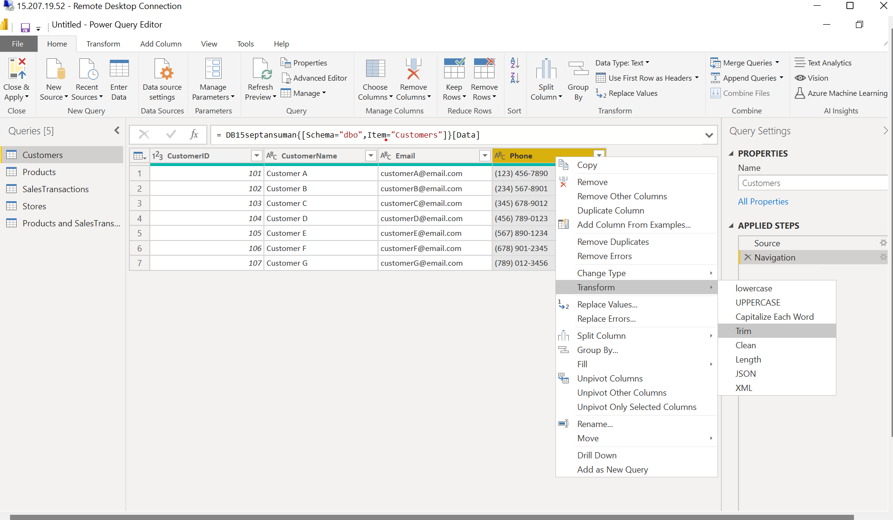

Replacing – with no space in Phone column table

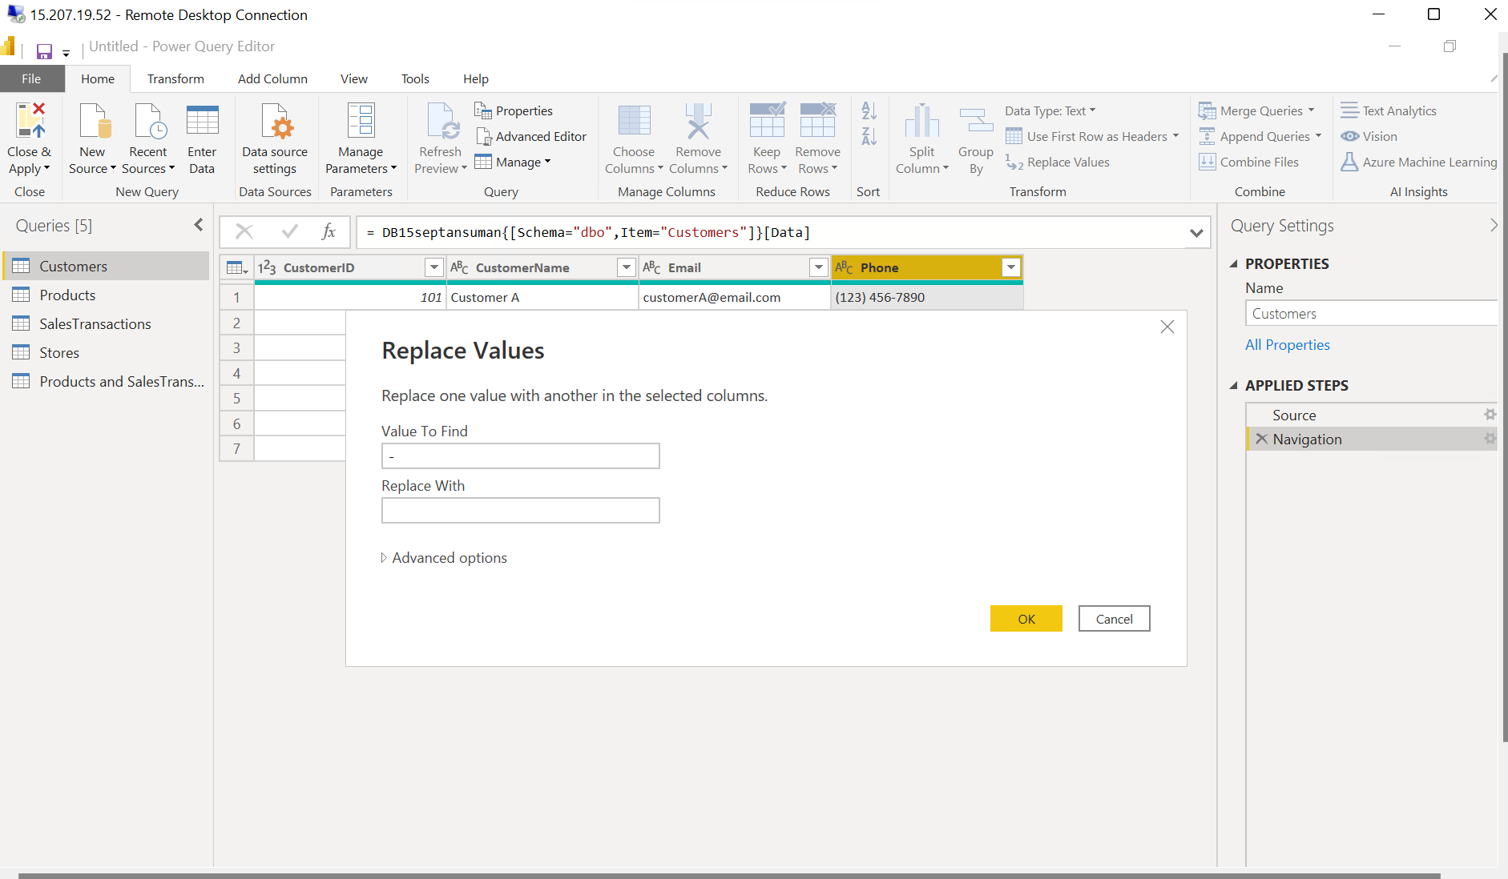

Removing ( ) from phone number

FILTERING DATA

Filtering based on Transaction data

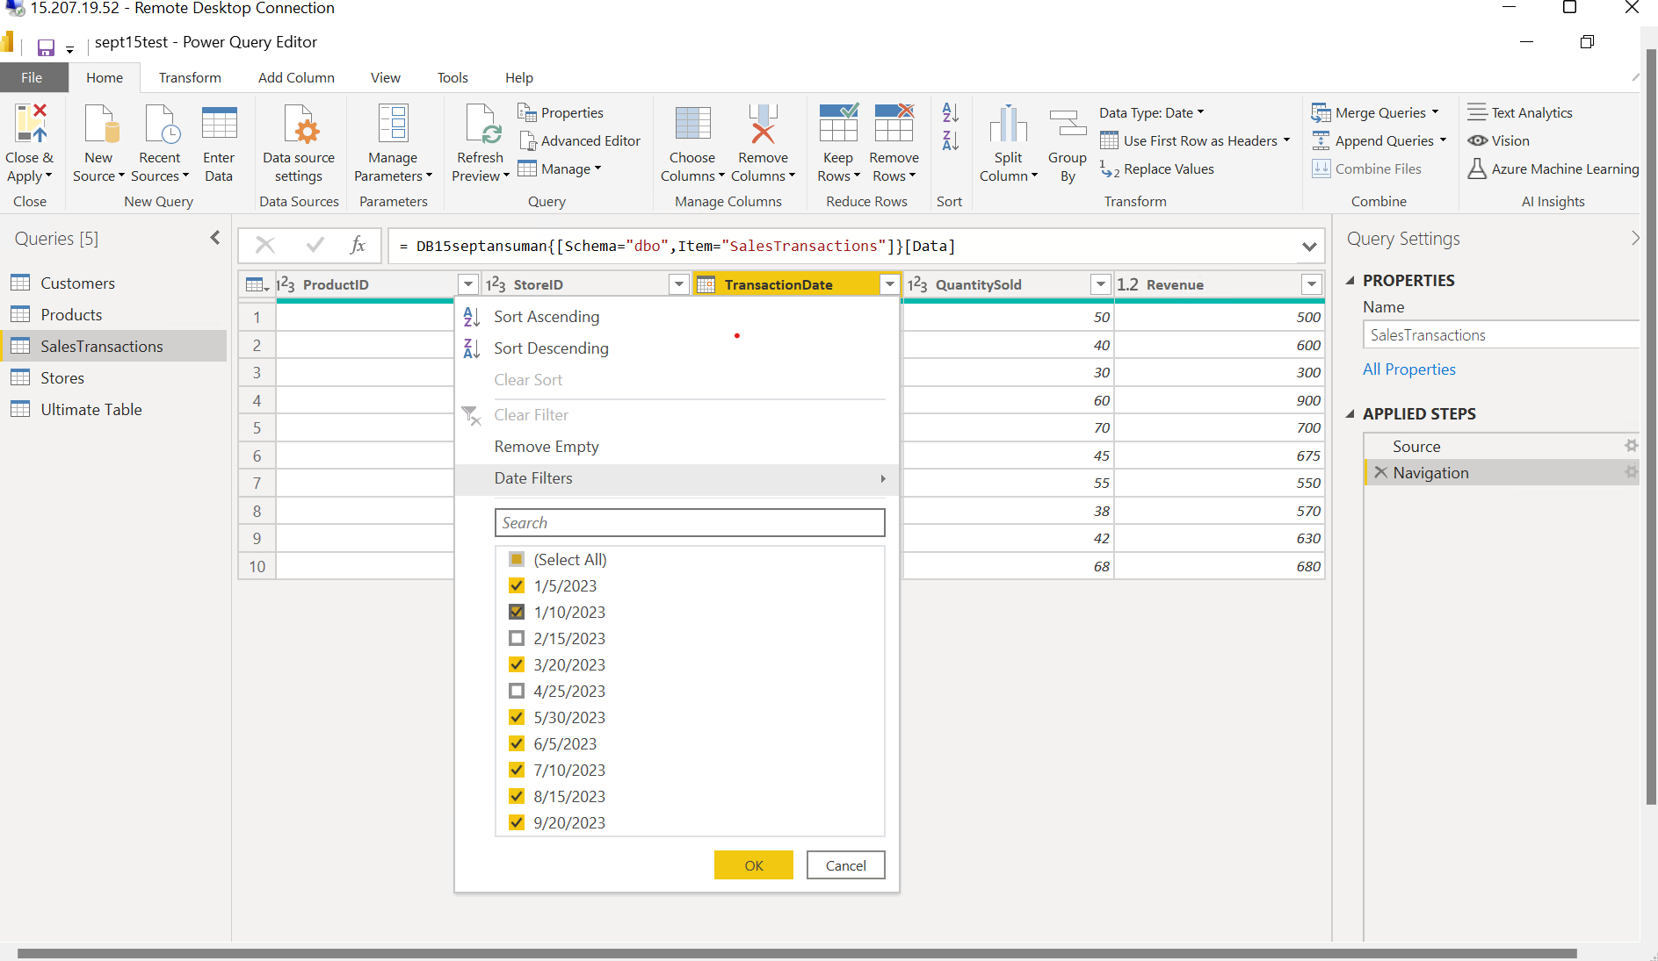

REQUIREMENT 3:

CREATING RELATIONSHIP AND HIERARCHY

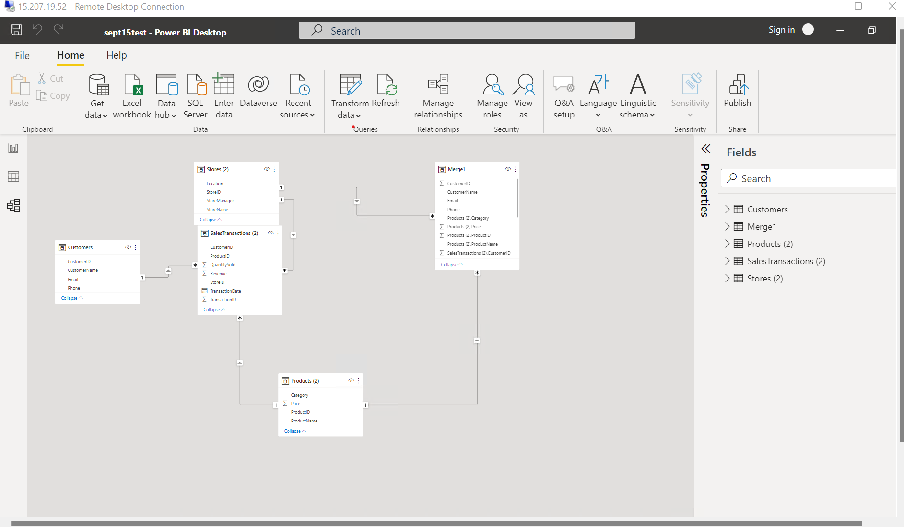

REQUIREMENT 4:

1. Who are the top-spending customers based on their total purchase amount?

Customer B and Customer E

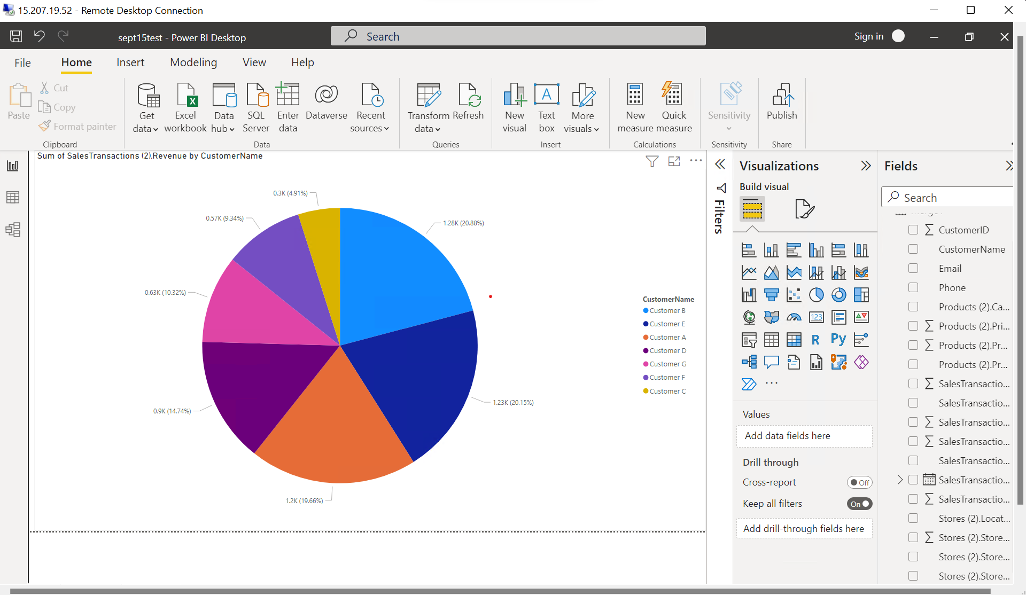2. How is sales revenue distributed among different store managers?

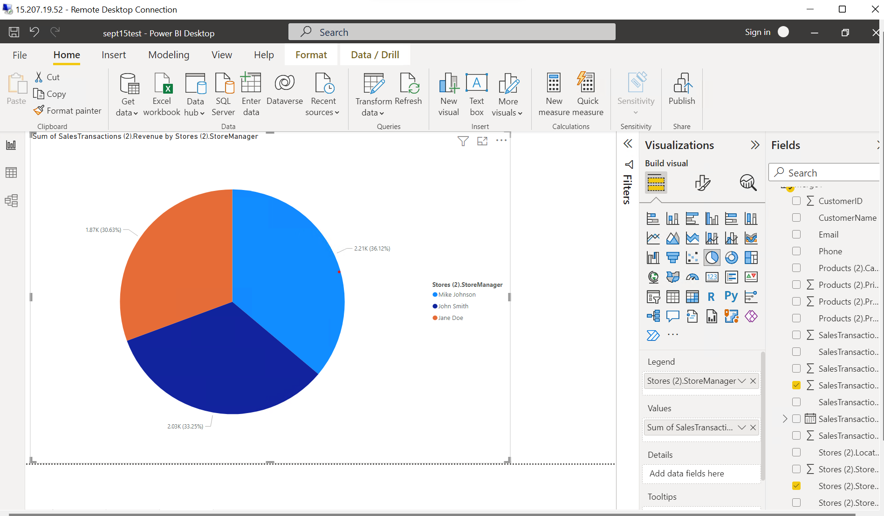

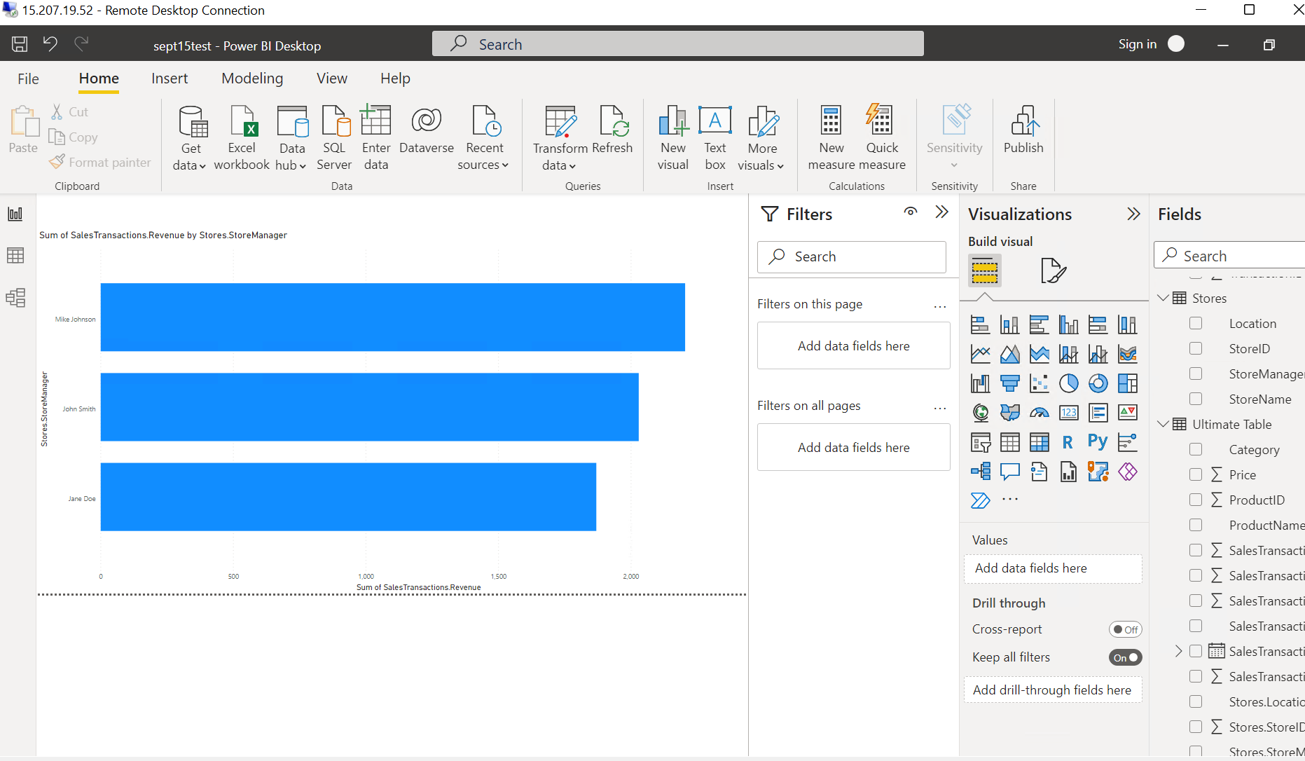

3. Average price of products in each Category

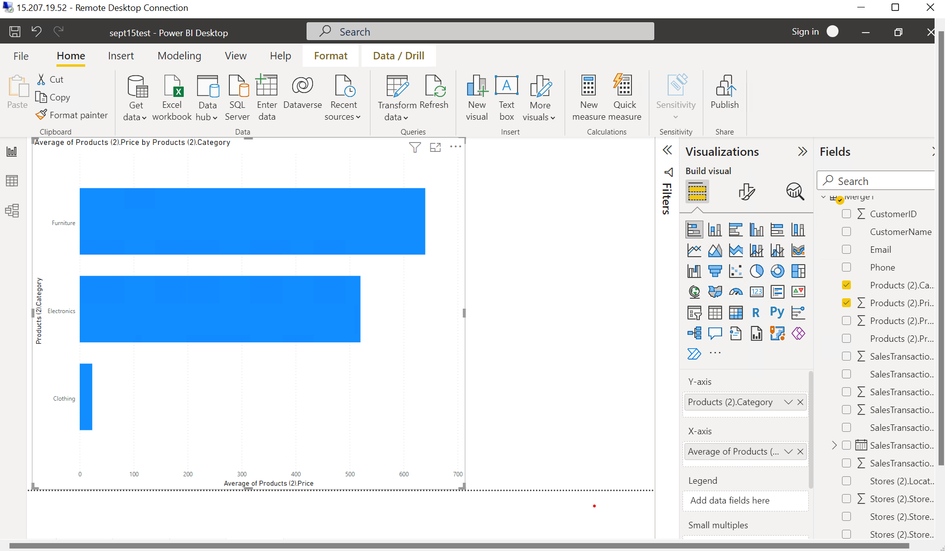

4. Are there specific days of the week when sales are higher?

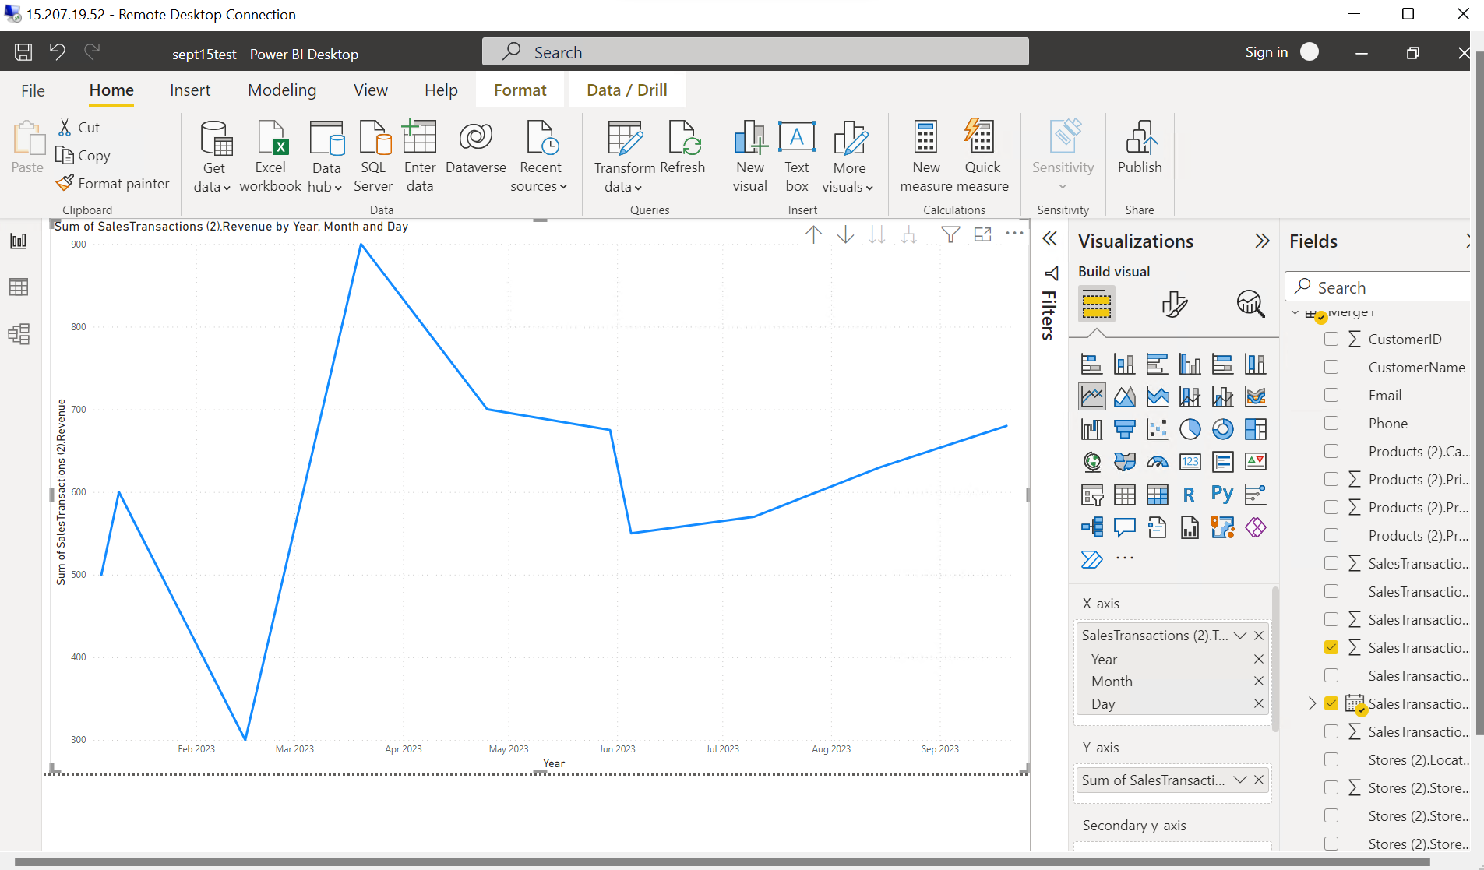

5. How do sales trends vary by product category on a monthly basis?

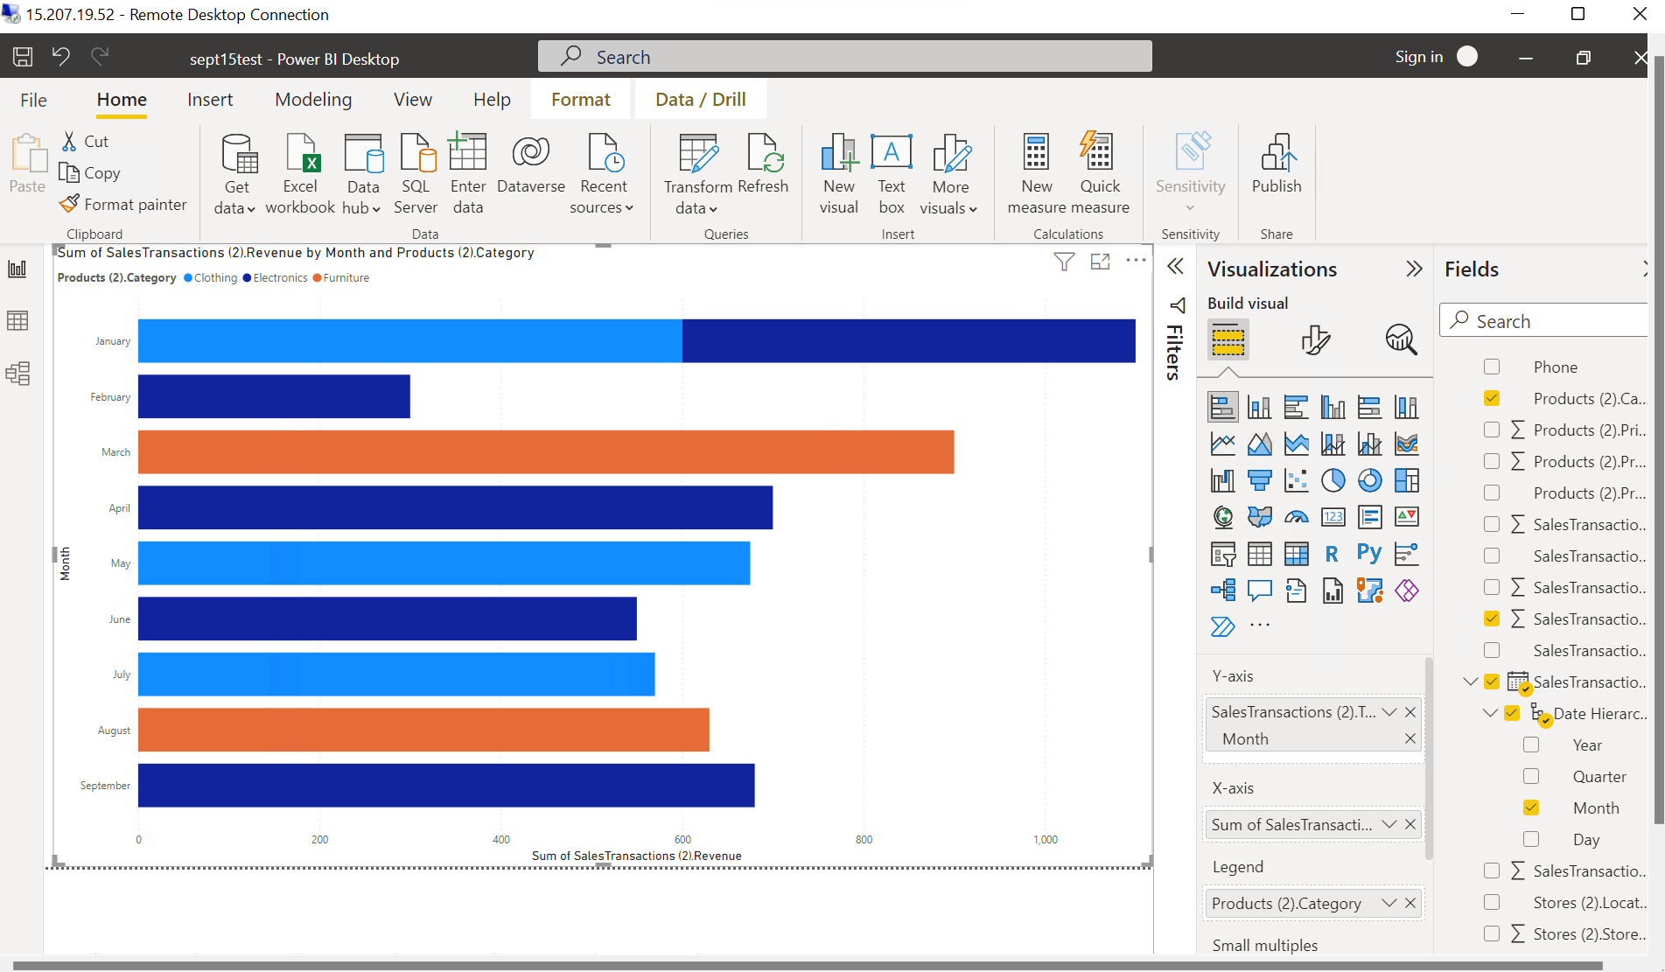

6.

7.

8. Which product categories perform best at each store location?

9. Are there any seasonal patterns or trends in sales for specific products or categories?

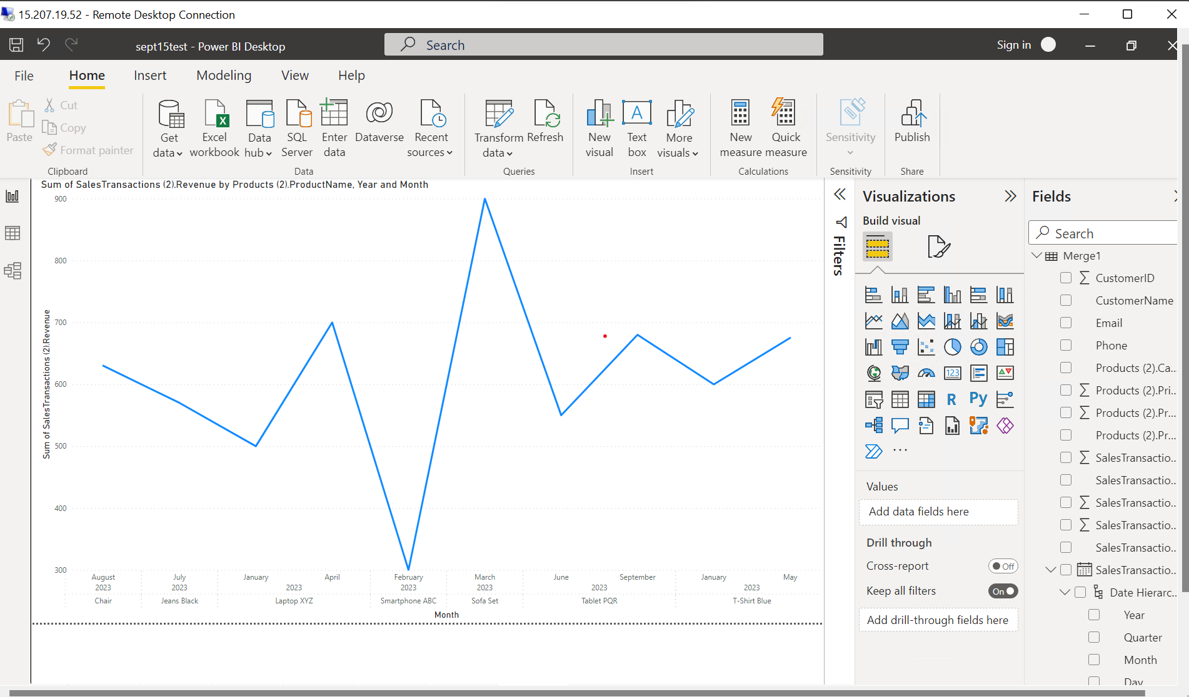

* Laptop sales increases from Jan to April
* Smartphones experience a stiff rise from Feb to March
* T shirt and Tablets gets a slight Increase

REQUIREMENT 5:

